# 

# 1 INTRODUCTION:

# 1.1 Overview A brief description about your project

Catering is the process or business of preparing food and providing food services for clients at remote locations, such as hotels, restaurants, offices, concerts, and events.

# 1.2 purpose The use of this project. what can be achieved using this.

* Service that cater/provide food service are also known as catering service
* Catering can also be regarded as a service that provides a pleasant change from home cooked food
* People like to enjoy snacks/beverages that have been prepared and served

2 PROBLEM DEFINITION & DESIGN THINKING:

**2.1 The empathy map screen shot**

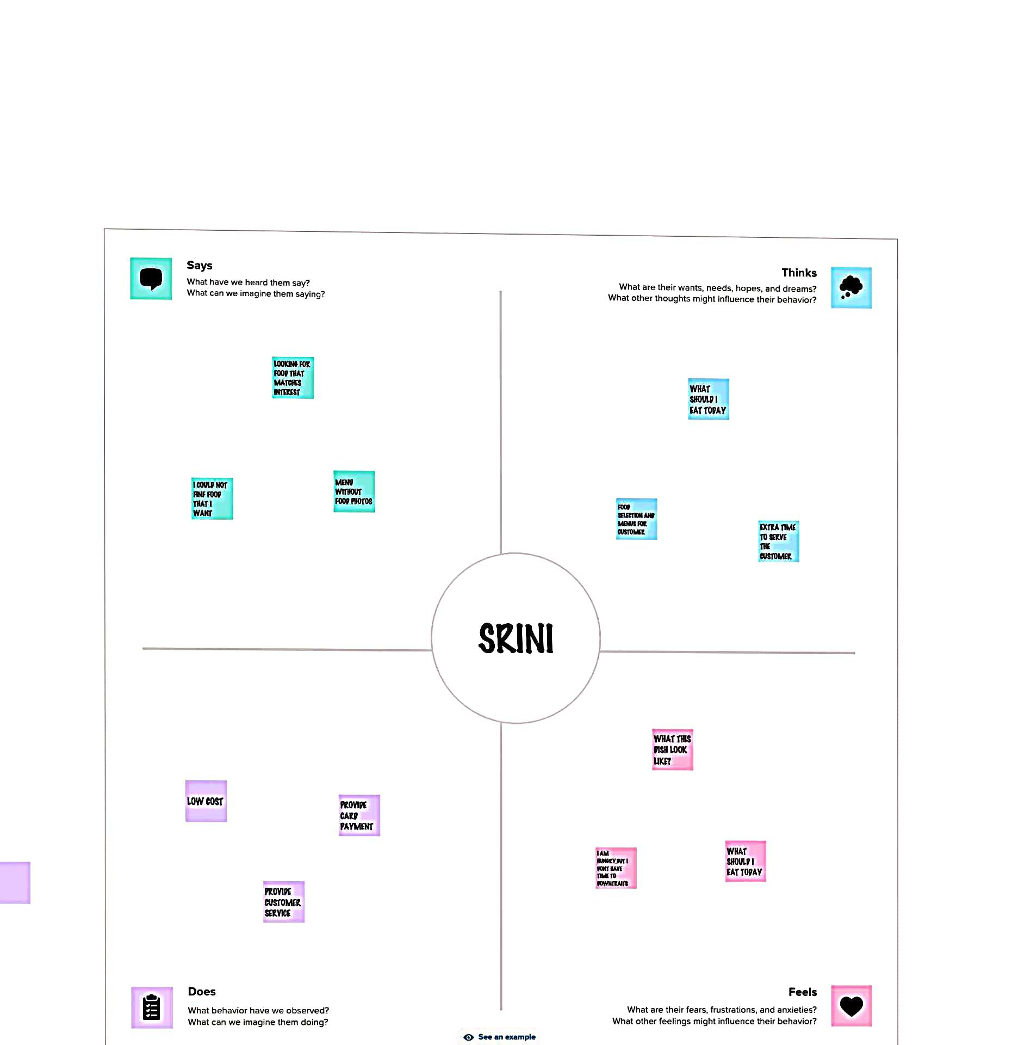

**2.2 Ideation & brainstorming map screen shot**

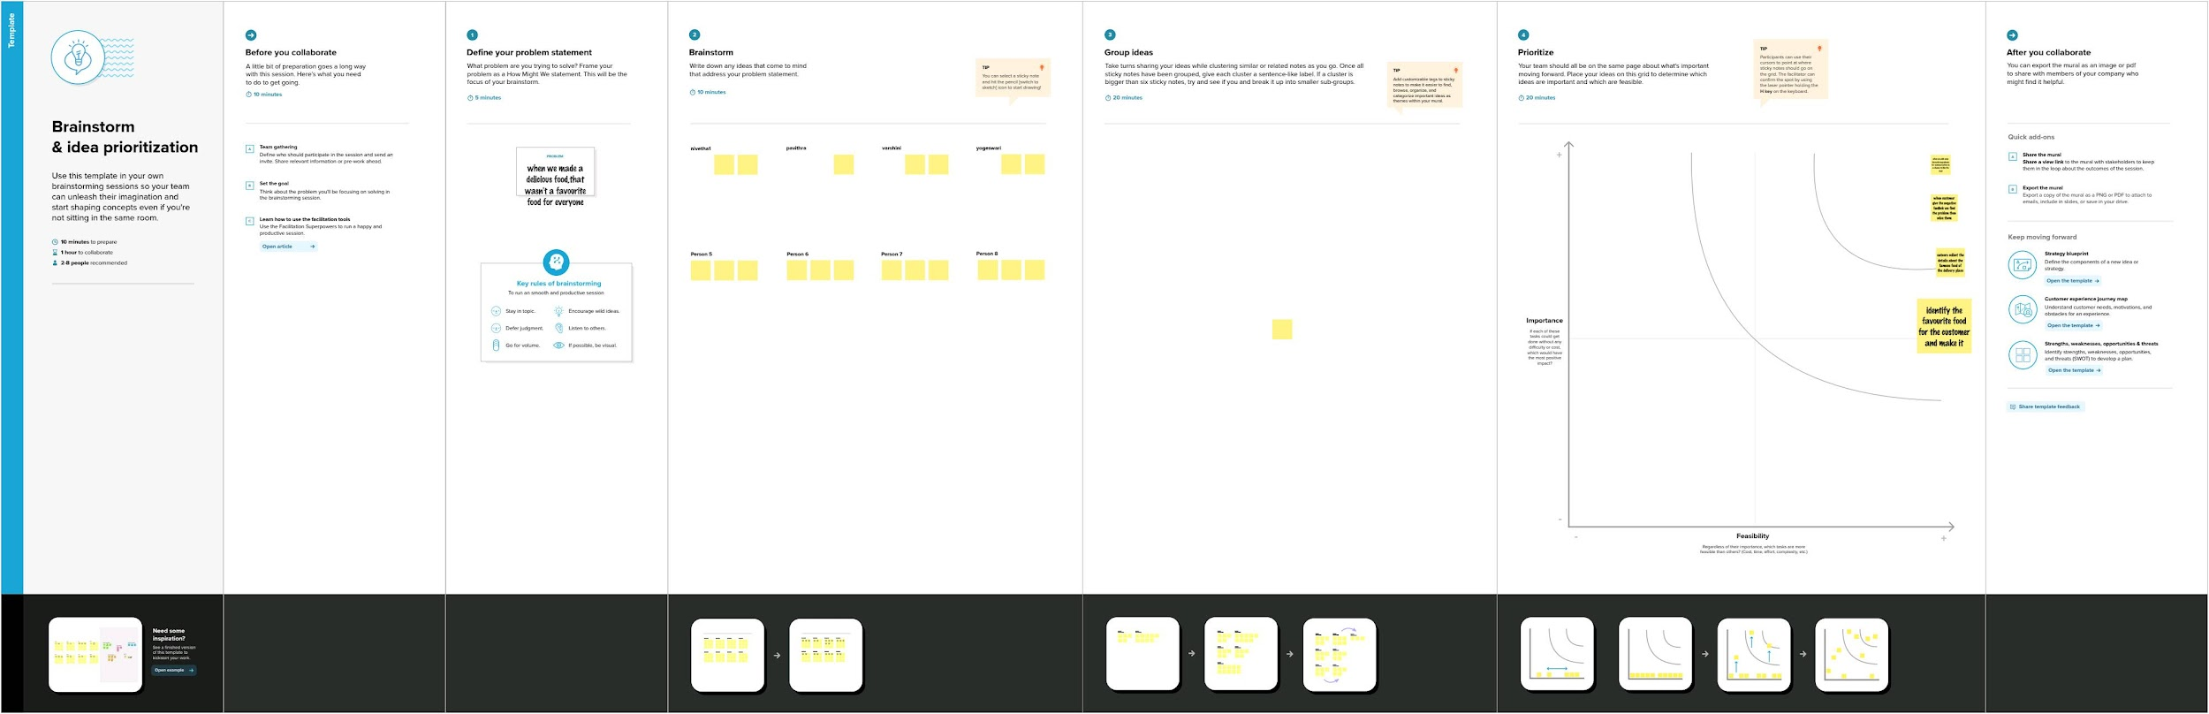

**3 RESULT**

**Final finding (output) of the project along with screenshots.**

**1.GST Reports:**

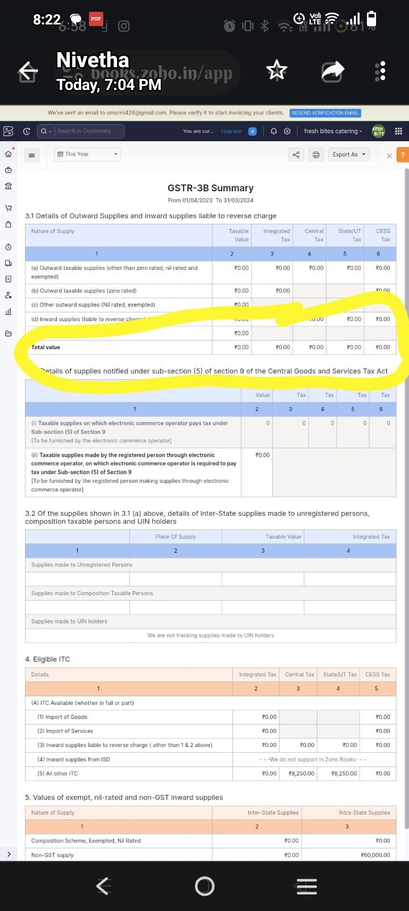

**2.Aging Receivable Summary.**

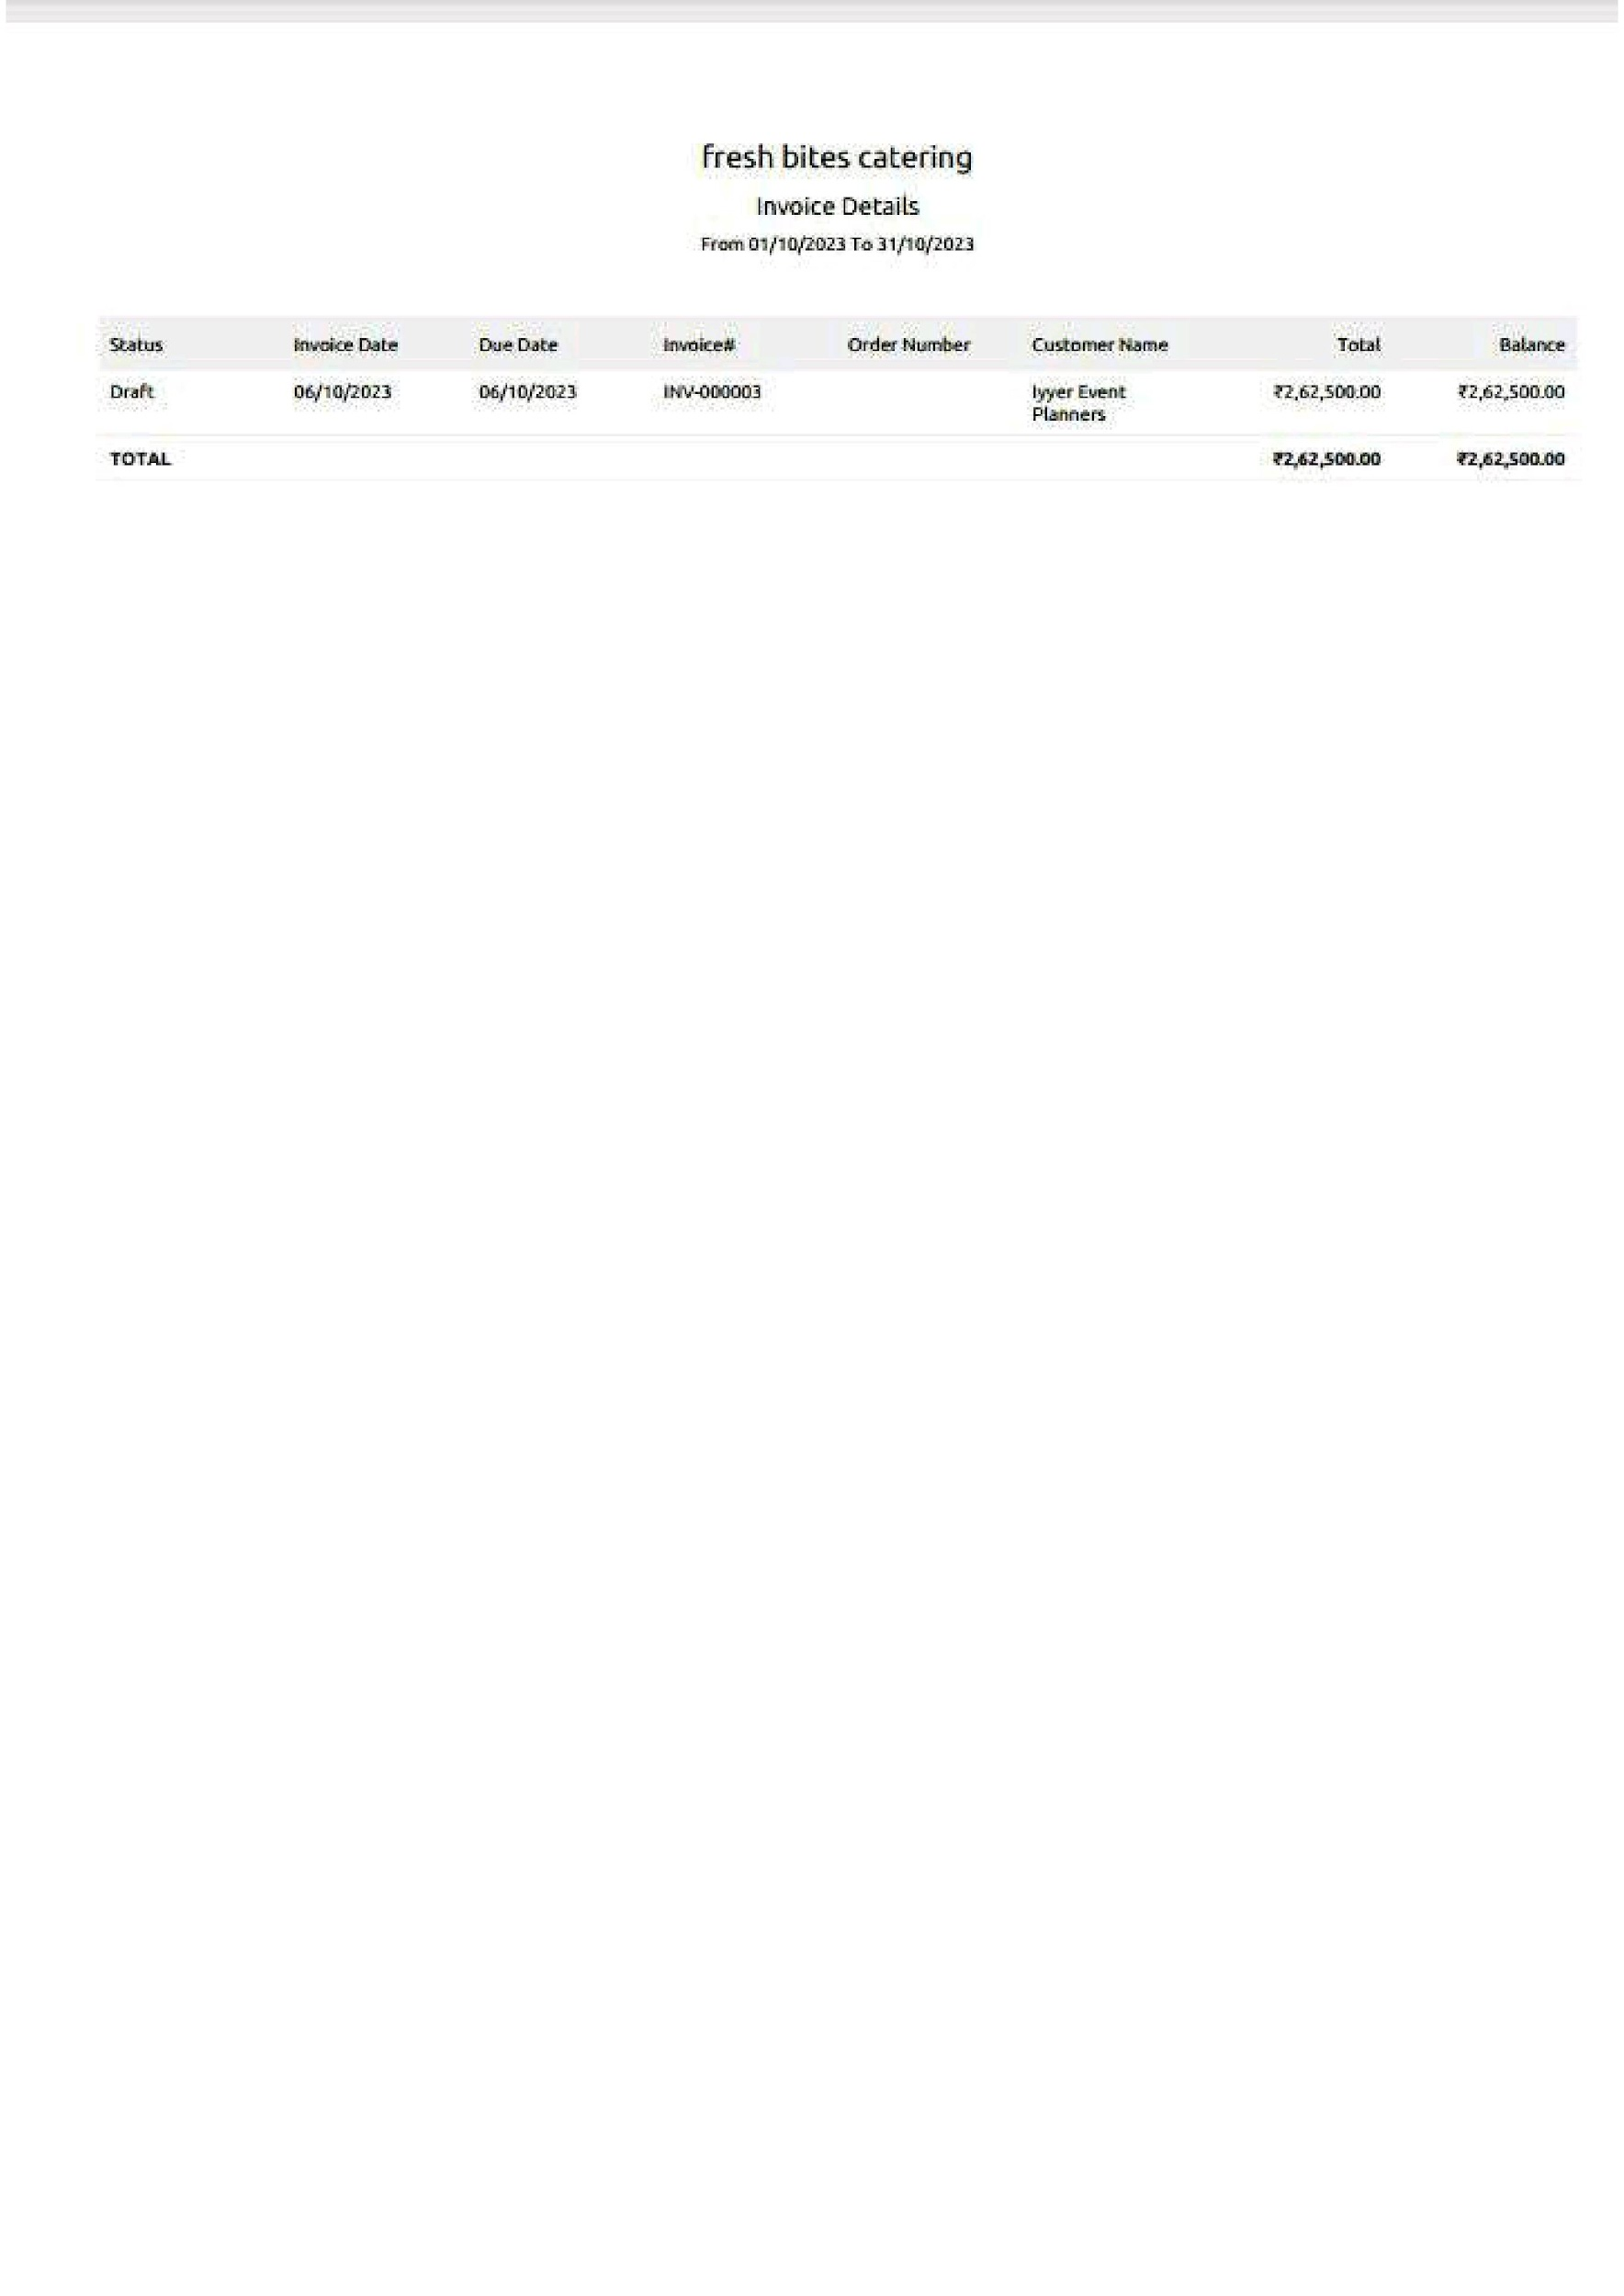

**3.Aging payable summary:**

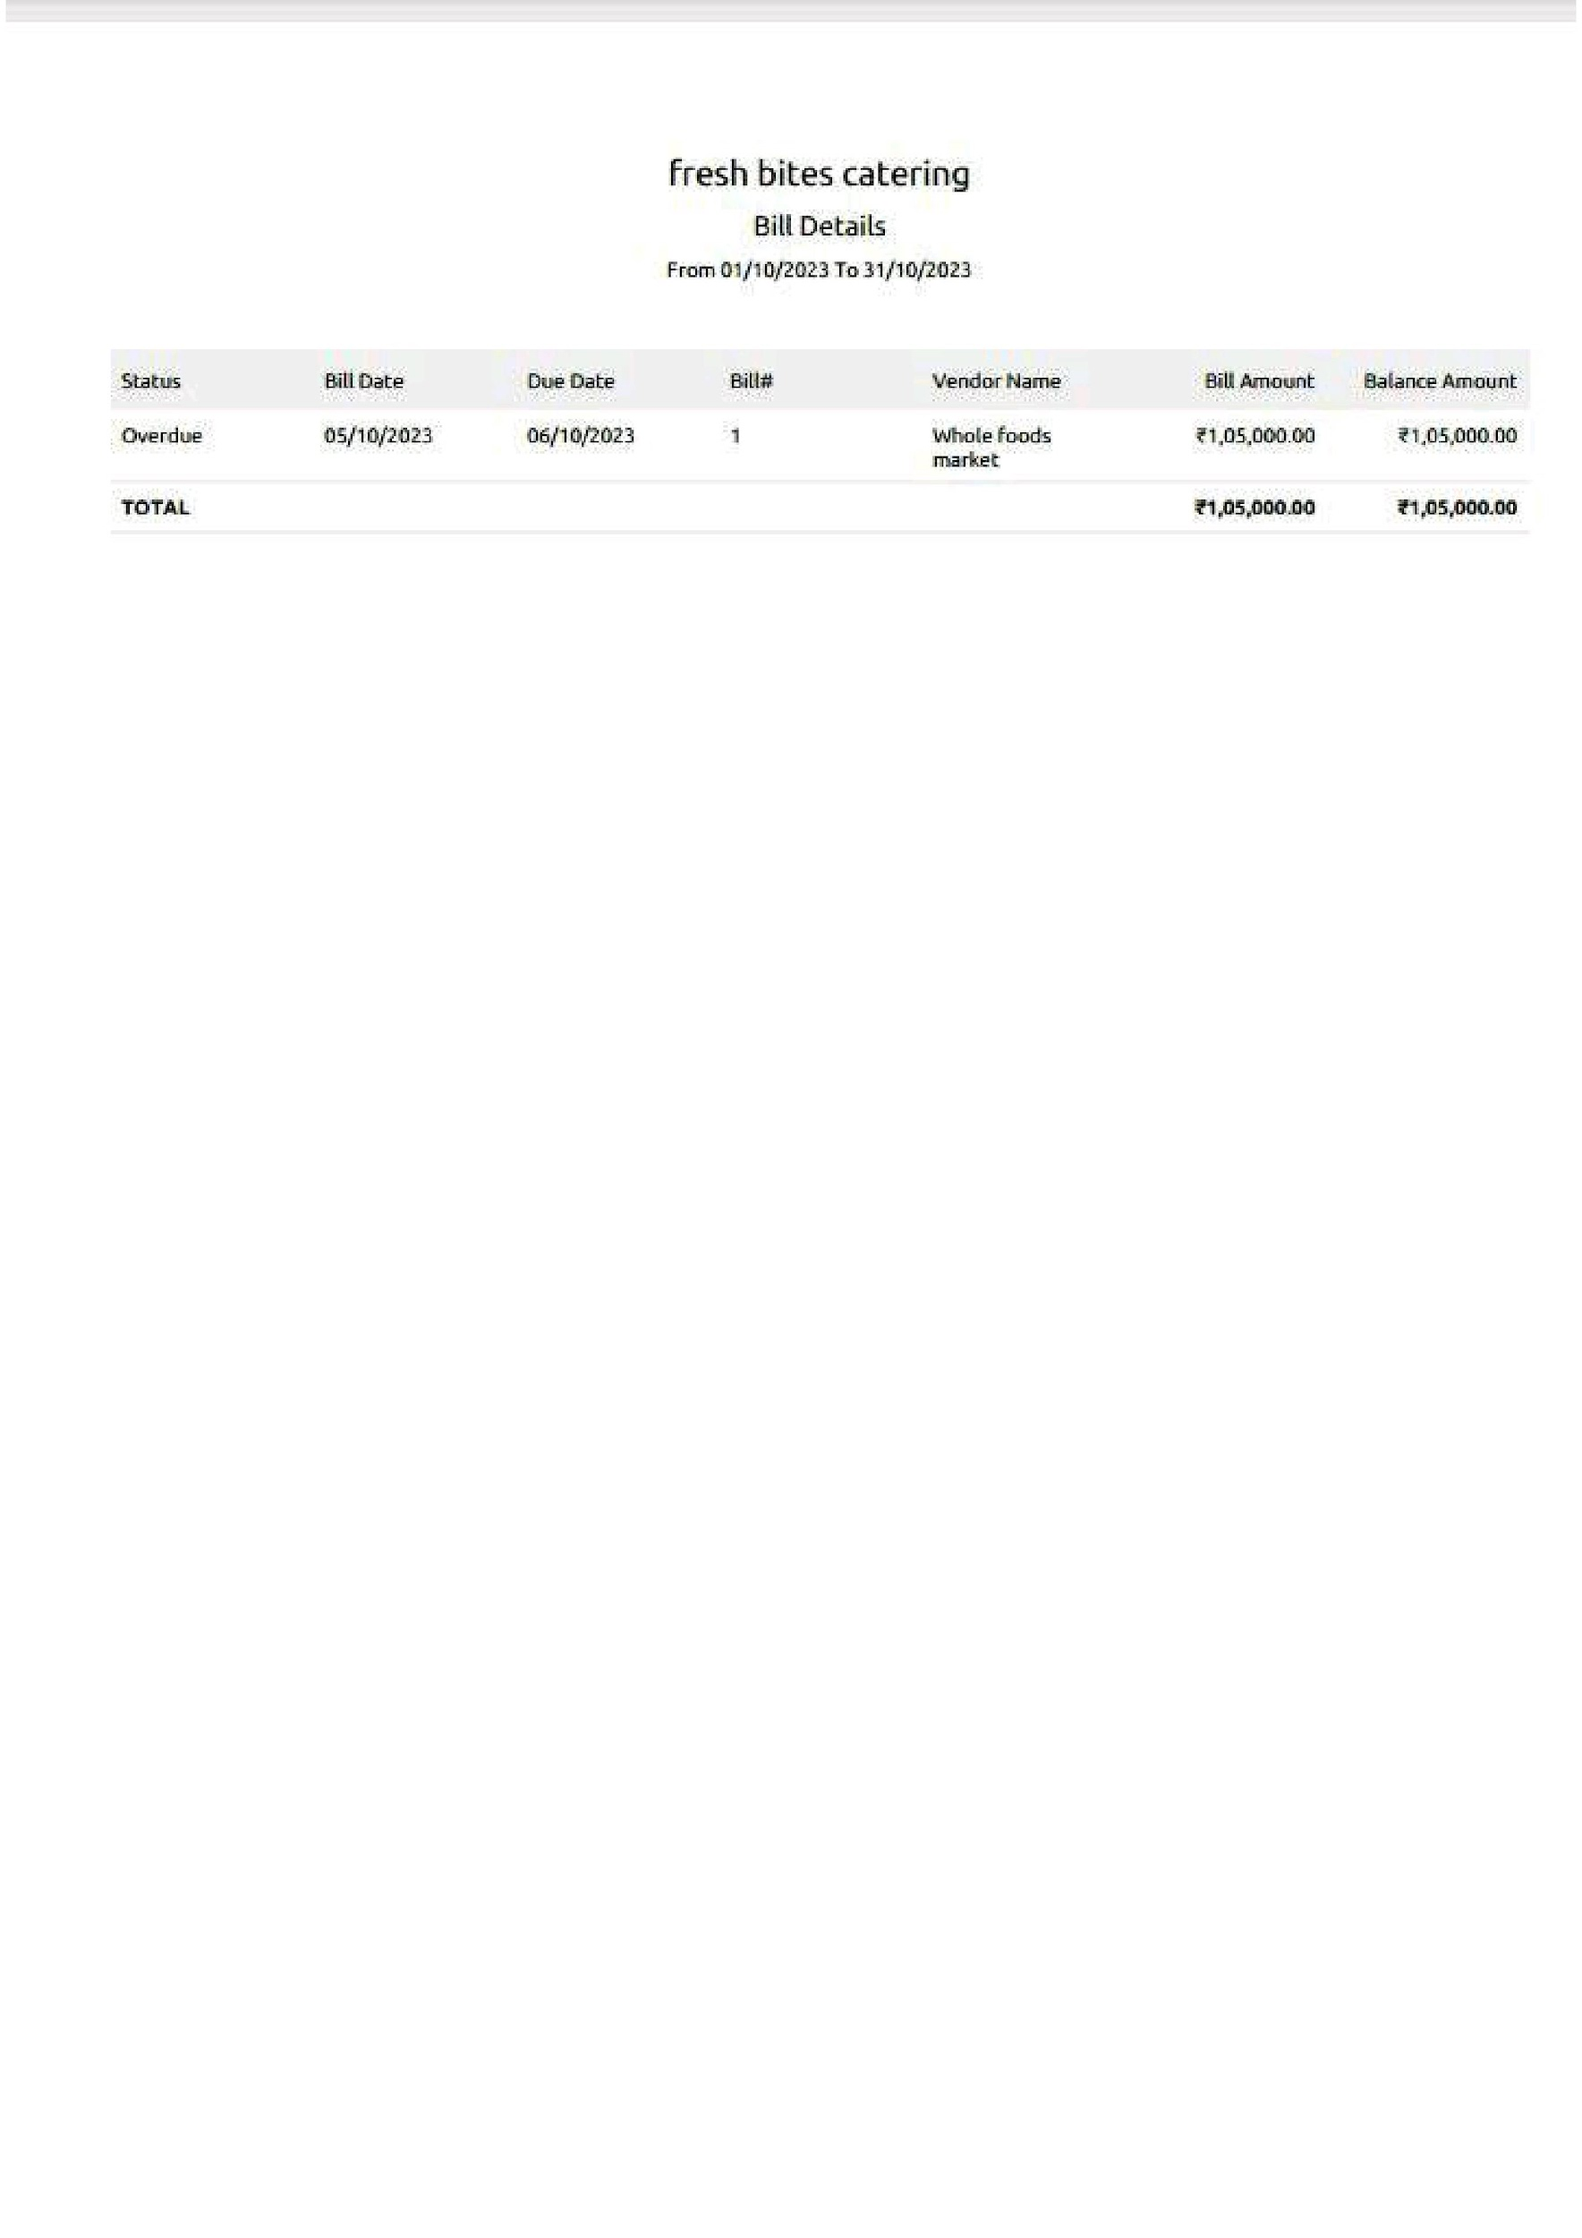

**4.Items**

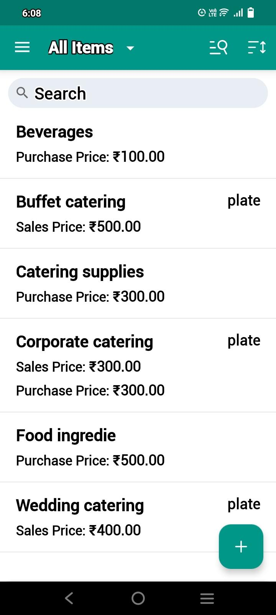

**5.Sales Invoices:**



**6. Purchase bills:**

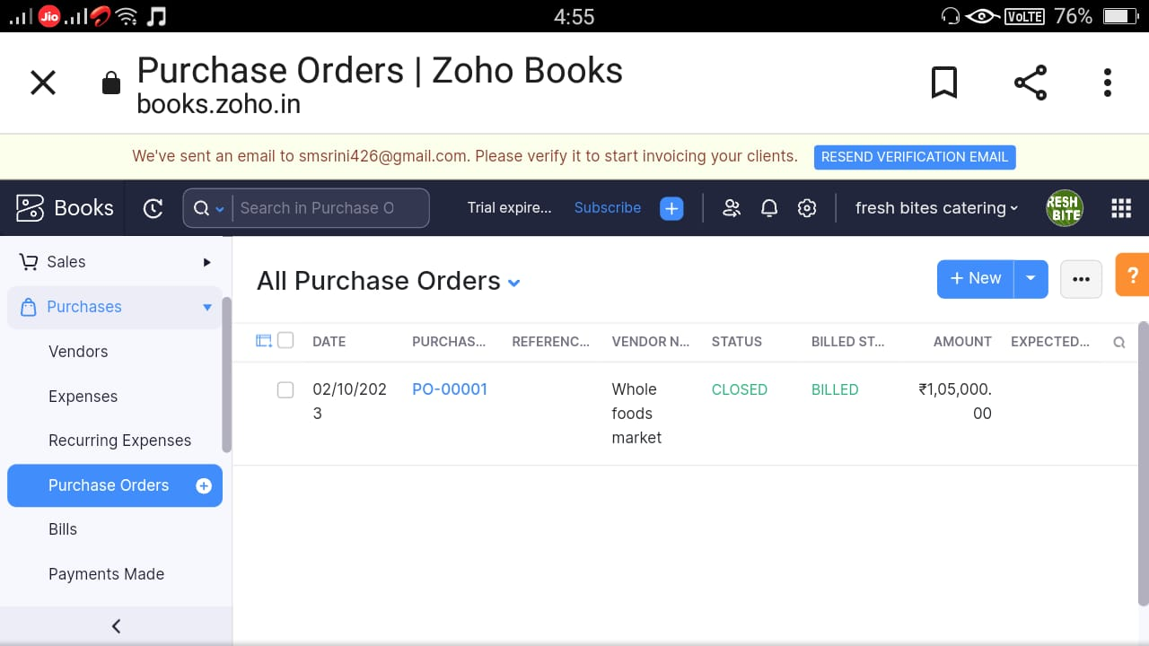

**7.Customer:**

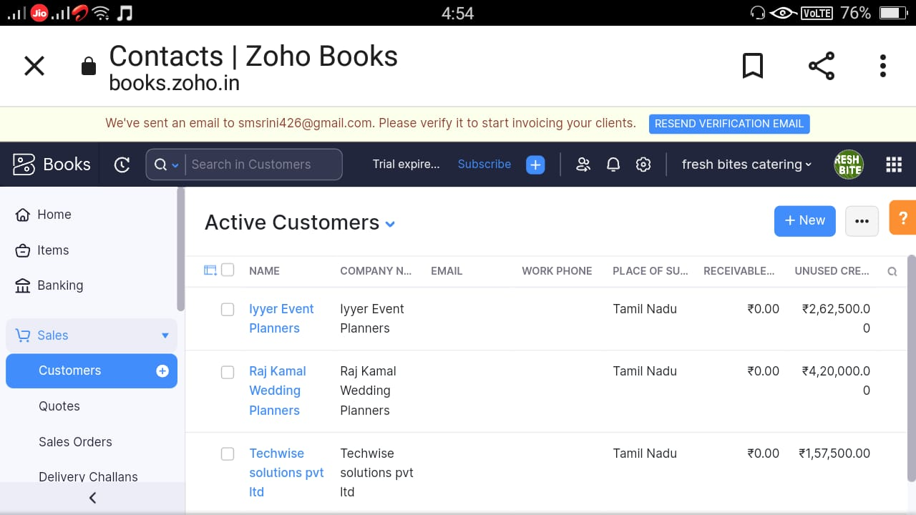

**8.Vendors:**

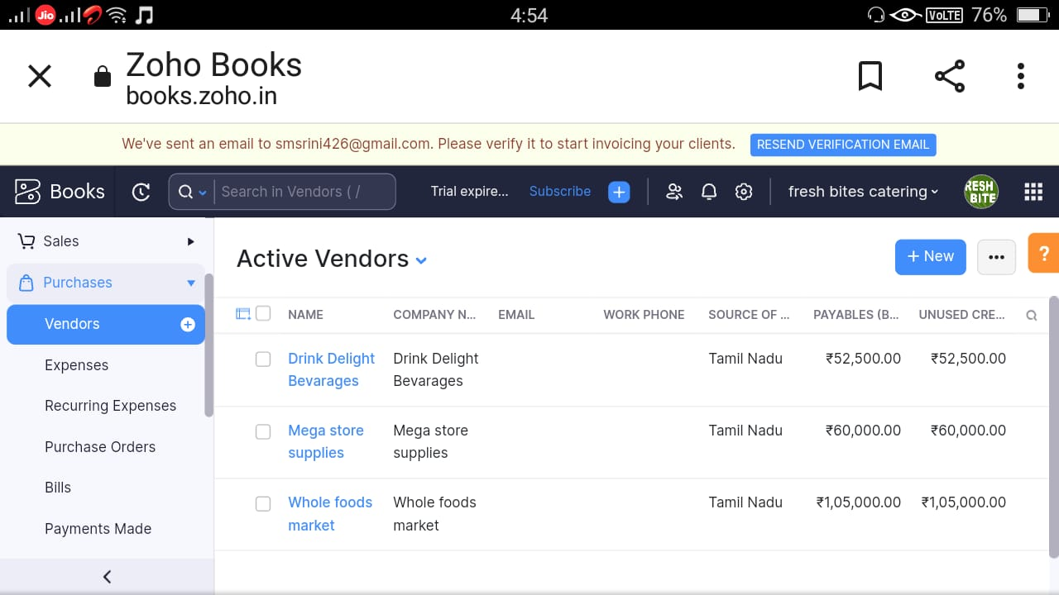

**9.Banking** :

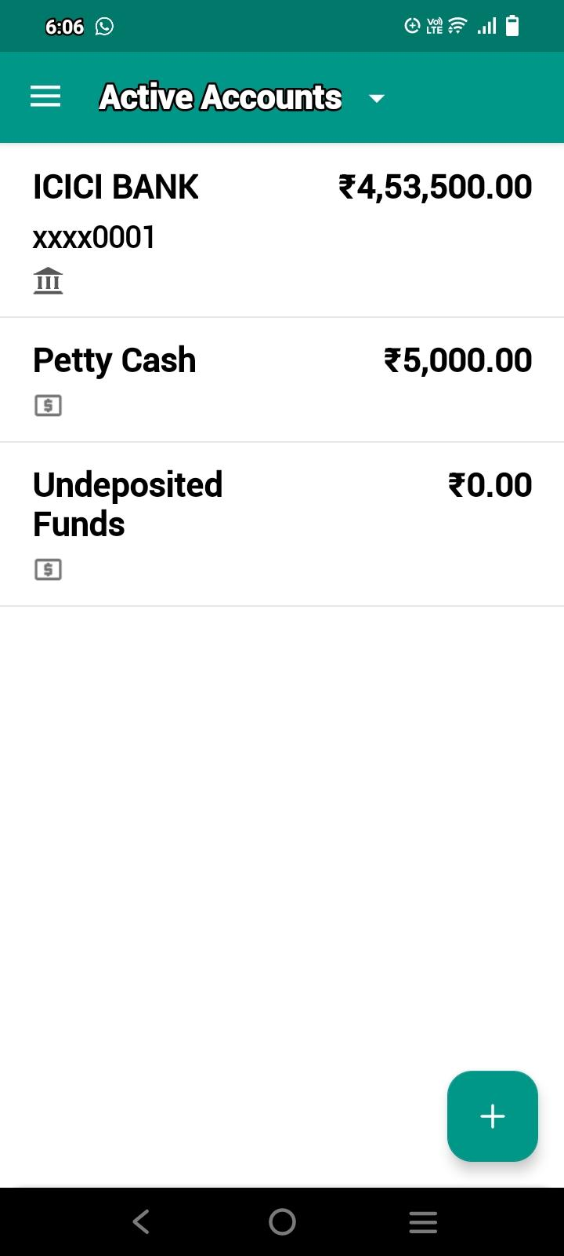

4 ADVANTAGES & DISADVANTAGES :

**Advantages:**

* Time saving this one of the catering benefits you are chosen cater will do the bulk of the work when it come to food
* They will buy the ingredients and make sure that there is enough food for all of your guests and cook the meal itself
* In fact they will deliver food for your event

**Disadvantages:**

* You'll have a lot of responsibility
* You'll be extremely busy
* You'll have a lot of stress
* It be difficult in the beginning of your career

5 APPLICATIONS:

1) customer Benefits

* Customer can be benefited by using this food catering by using this food catering service they can be benefited in Such a way our customer precious time can be saved , and many other applications like this

6 CONCLUSION:

* + **This edition include far reaching suggestion for research that could increase the impact from the customer they can be attracted by our work**

**1.profits & loss Report:**

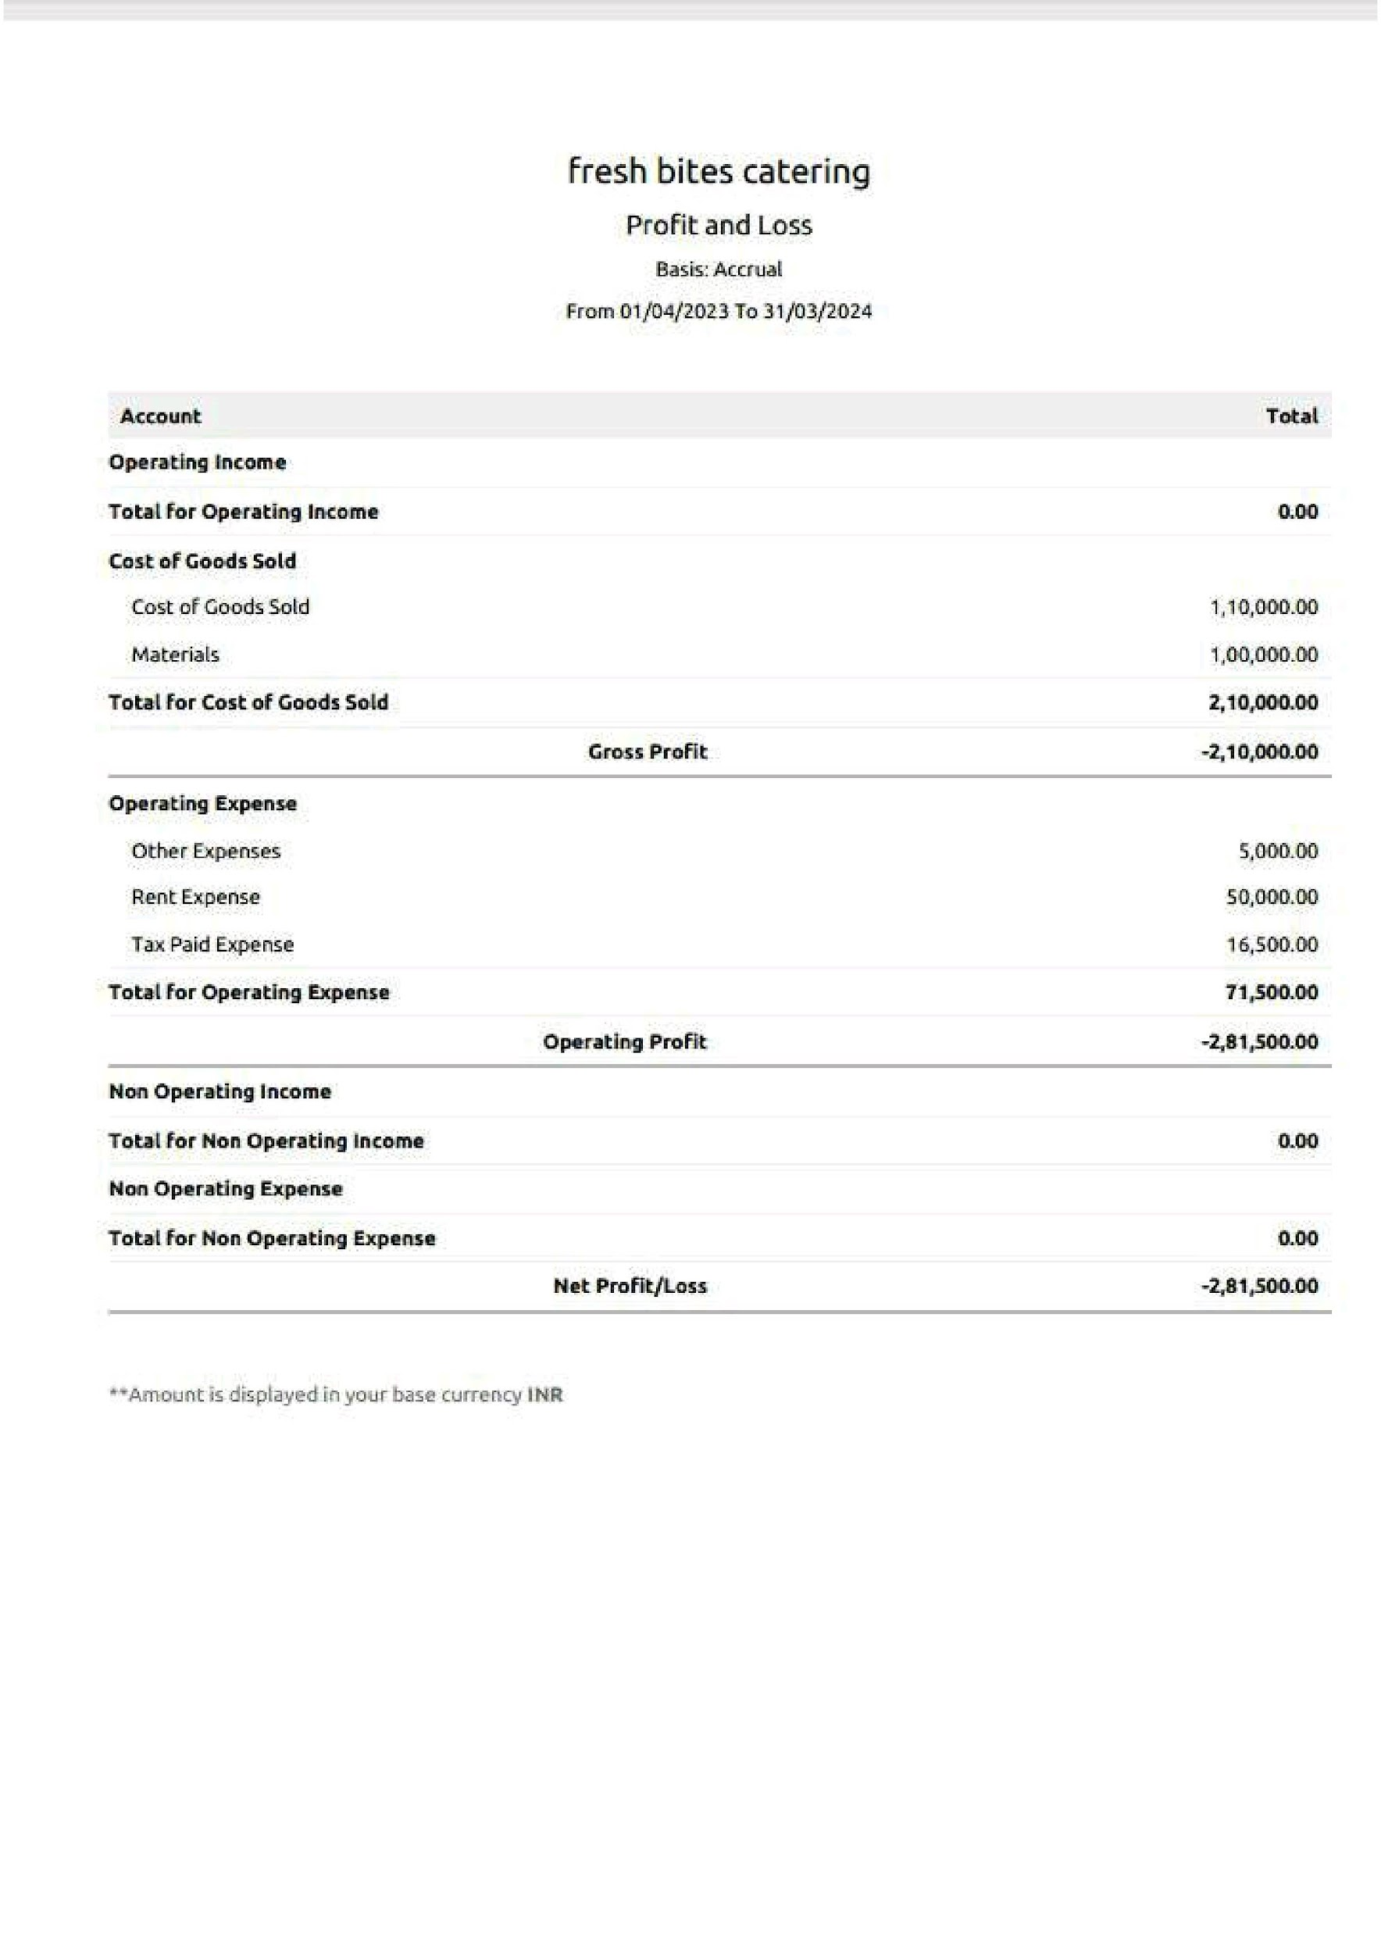

**2.Balance sheet Report :**

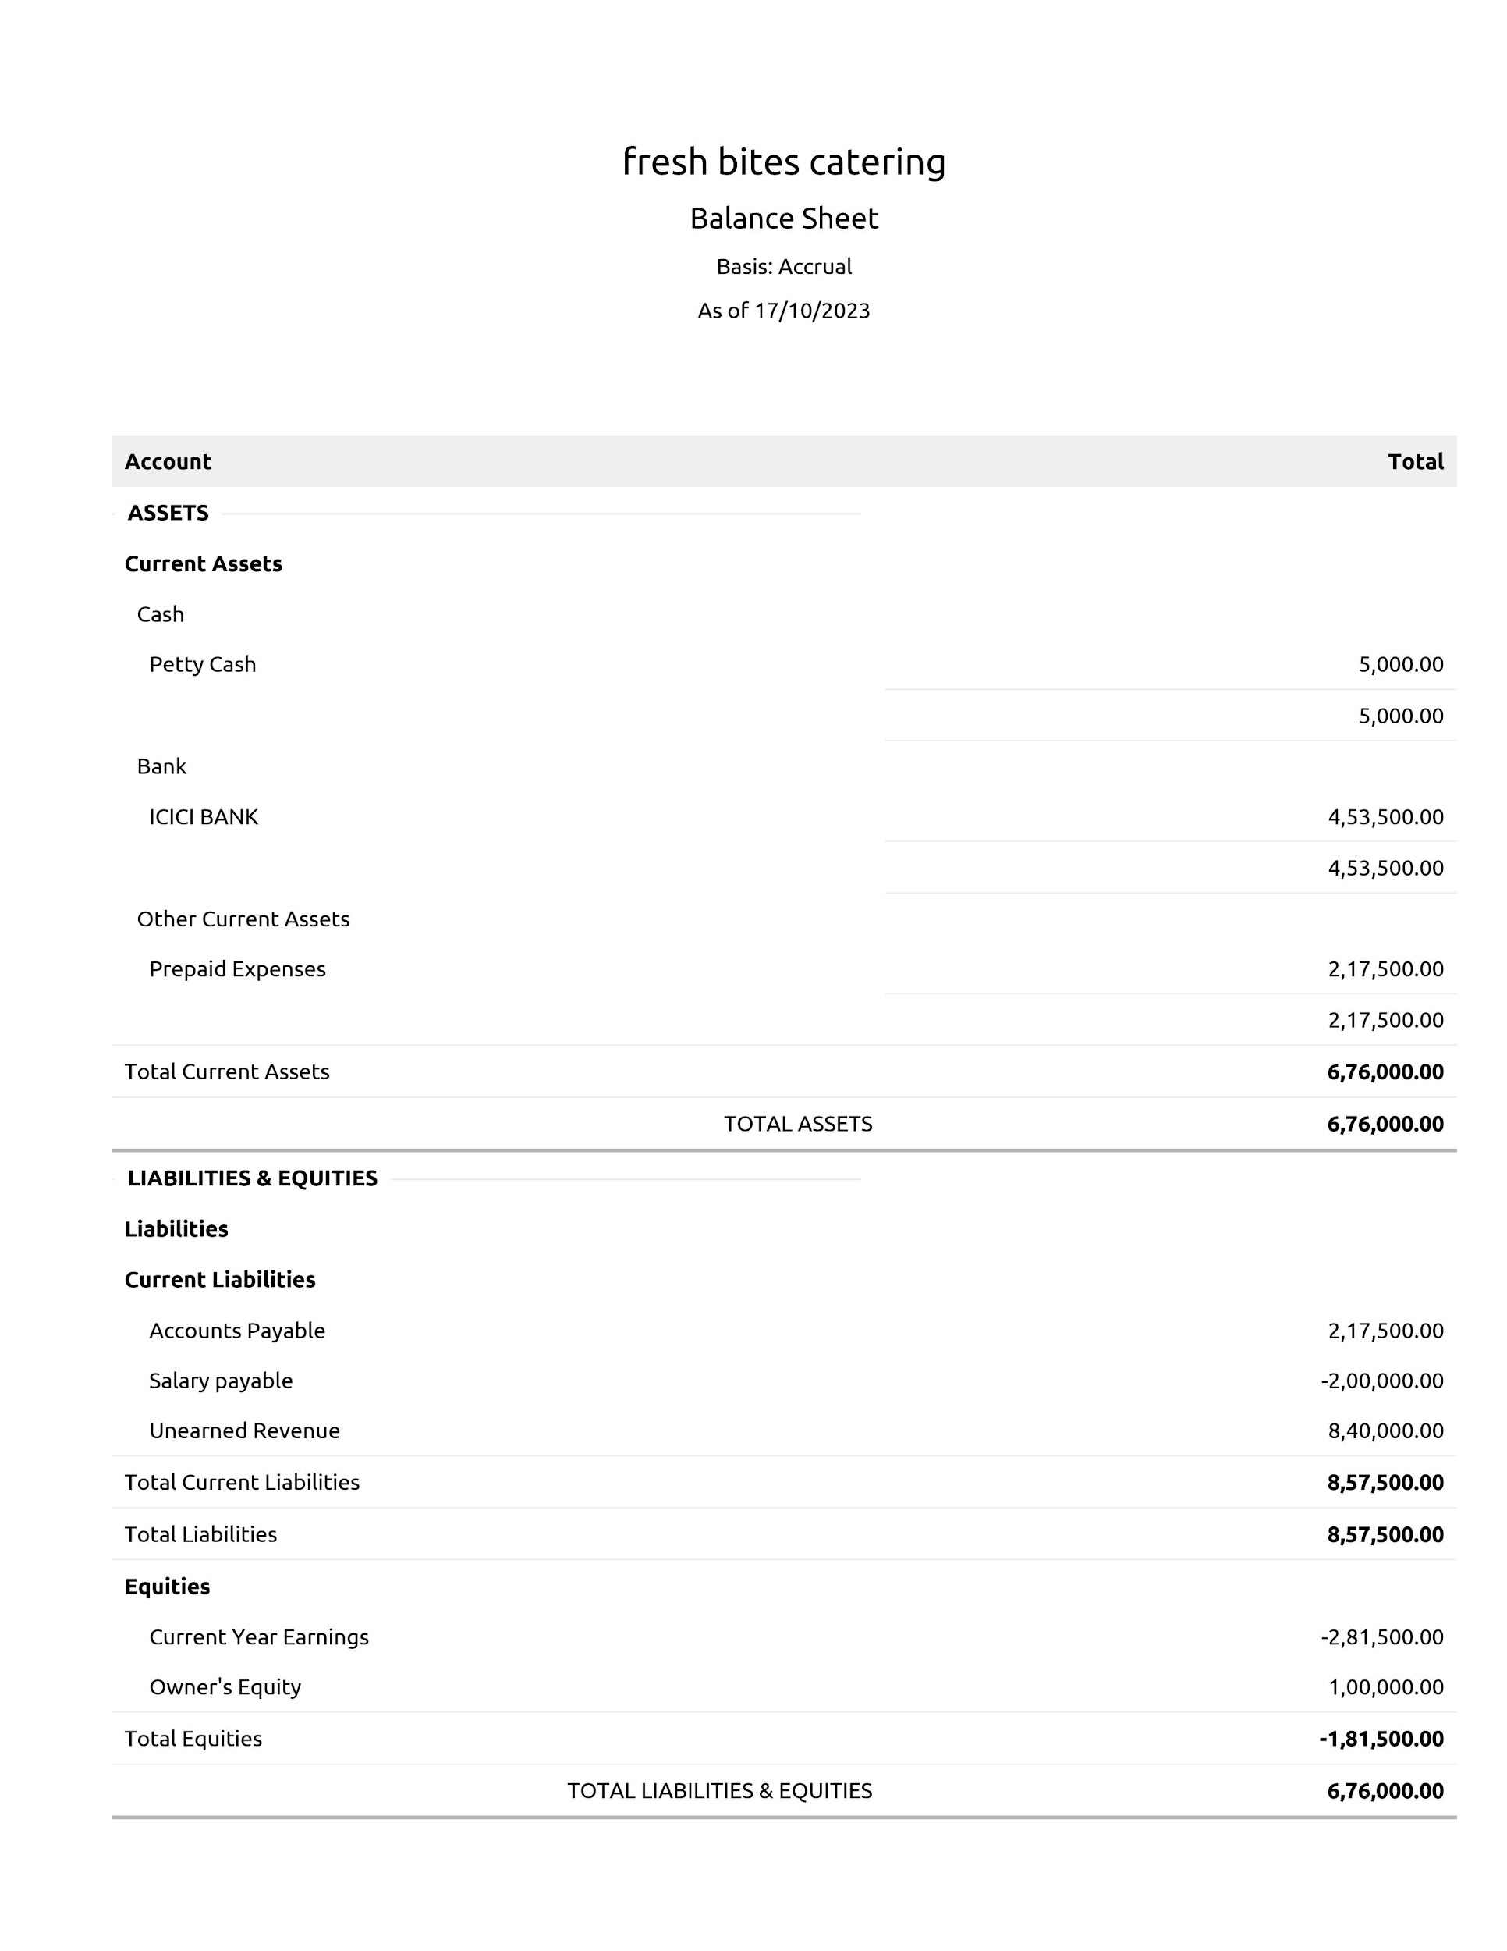

7 FUTURE SCOPE:

**India captain service market is going at CAGR of ~%in 2017-2022**

**Under expected to reach you USD ~Bn buy 2027 f the Indian catering service market is largely drive by increasing urbanization and the increase of tourism in the country**

**Personalization is becoming increasingly important in the caterings industry as consumers seek out unique customized experience caters or responding to the strength by offering more personalized menu service and dining experience**

**In future the industries witnessing a shift towards healthier and organic food products the move to healthier option is very visible in India the customer has become wiser during and has realized the effect of food on various aspect of health particularity**

**By 2050 the world's population is forecast to surpass 10 billion people to keep pace with population growth the United Nations estimate the global food supply will need to increase 50 percentage over current volume to accommodate project demand**

**In future he catching system is essential for the following food is consistency prepared to the highest quality standard it is designed the meeting the same quality of days textures and presentations regardless of how many service are offered**

**Nowaday food is so essential for everybody so the catering system is very important for future hence the food catering system will helpful to people and the society to become healthy world**

8 APPENDIX:

Catering APPENDIX

According to try mark as you can see some of the main challenges in running a catering business or

logistical and there is no way around that after all feeding a lot of people will a challenge that requires strategy in planning because the largest dominant the business

"Feeding a lot of people will always be challenges in the catering service"